

G2 EE

Drop Shipment

QAD EE Training Document

Drop Shipment

Table of Contents
Objective 3
*Link SO and PO 5.5.1.20 3

Objective
Purpose of this document is to explain the Drop Shipment process.
In order for this process to work the SO and PO must be set up. See instructions Supplier PO Setup and Customer SO Setup for details.

*Link SO and PO 5.5.1.20
This program is used to create the link between the Sales Order and the Purchase Order with the supplier.
Enter the details and click next.
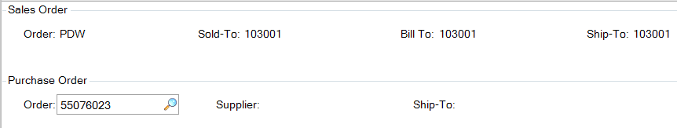
Click Next to confirm and you will return to the Order field. Click Next and you will be shown the POs linked to that order.
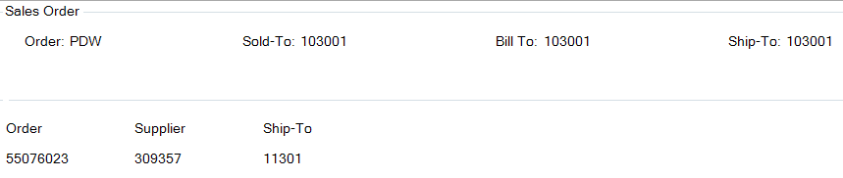

To delete a link:
Enter the sales order as above and click Next. You will see the link you want to delete with any other links to that SO. Click Next and enter the PO that you want to remove the link with. You will be asked if you want to confirm delete. Select Yes.
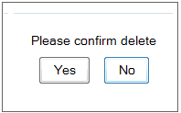
Once the required link between the PO and SO has been established use the standard receipt process to receive the goods. Follow the Goods Receipt instruction.
Receipt of the goods will automatically create the Shipper with the Delivery Note number form the receipt. You will be able to see it in 7.9.4 and confirm it in 7.9.5. For more details see the Shipping instruction.

